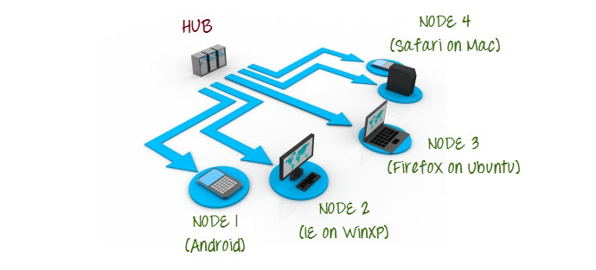

Commands in Hub Machine

1.Setting Up Hub:

**java -jar selenium-server-standalone-2.44.0.jar -role hub**

**2.Validating Hub started**

[**http://localhost:4444/grid/console**](http://localhost:4444/grid/console)

Commands in Node Machine

**3.Accessing Hub from Node Machine**

[**http://iporhostnameofHub:4444/grid/console**](http://iporhostnameofmachinea:4444/grid/console)

**4.Registering Node with Hub**

**Java –jar selenium-server-standalone-2.44.0.jar –role webdriver –hub** [http://iporhostnameofHub:4444/grid/register -port 5566](http://iporhostnameofHub:4444/grid/register%20-port%205566)

**Code in Hub Machine**

**import java.io.File;**

**import java.net.MalformedURLException;**

**import java.net.URL;**

**import java.util.concurrent.TimeUnit;**

**import org.junit.Test;**

**import org.openqa.selenium.Platform;**

**import org.openqa.selenium.WebDriver;**

**import org.openqa.selenium.firefox.FirefoxDriver;**

**import org.openqa.selenium.firefox.FirefoxProfile;**

**import org.openqa.selenium.remote.DesiredCapabilities;**

**import org.openqa.selenium.remote.RemoteWebDriver;**

**import org.testng.annotations.AfterMethod;**

**import org.testng.annotations.BeforeMethod;**

**public class Testparallel {**

**//protected ThreadLocal<RemoteWebDriver> threadDriver = null;**

**public static void main(String[] args) throws MalformedURLException {**

**WebDriver driver;**

**DesiredCapabilities capabilities = DesiredCapabilities.firefox();**

**capabilities.setCapability(FirefoxDriver.BINARY,new File("C:\\Program Files (x86)\\Mozilla Firefox\\firefox.exe").getAbsolutePath());**

**driver = new RemoteWebDriver(new URL("http://192.168.0.106:5566/wd/hub"), capabilities);**

**driver.get("http://google.com");**

**System.out.println(driver.getTitle());**

**}**

**}**